**18. Introduction to Amazon API Gateway**

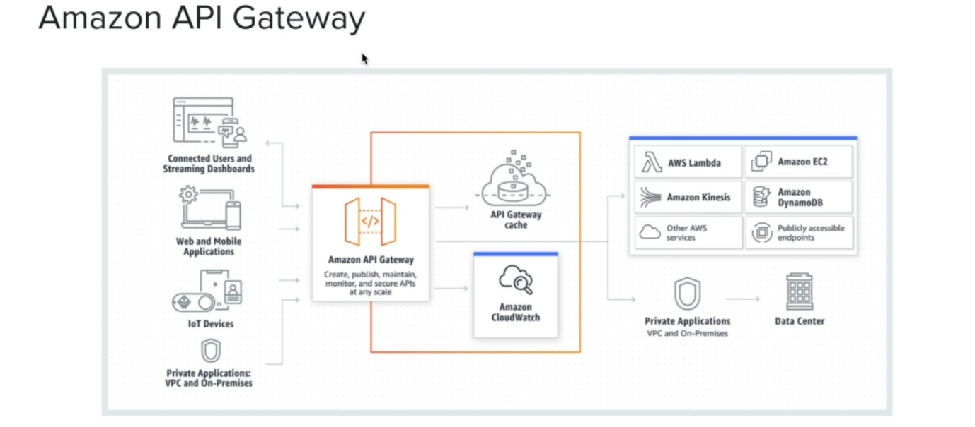

* let us have a look at Amazon API Gateway. Now Amazon API Gateway is a fully managed restful API service offering from AWS. Now, as you can see in the diagram, Amazon API Gateway can be accessed by web, mobile applications, IOT devices, private applications that are inside a private network like a VPC or on premises and so on and so forth.
* Now we are particularly interested in accessing Amazon API Gateway through web or mobile applications. Now, since this restful API, we usually access through a http protocol. So, web and mobile application can make a http request in terms of get, post, delete, update and so on and Amazon API Gateway will respond to those requests.
* Now when we create an API gateway, we can enable API gateway caching as well. For example, if there is a get http request, maybe the API gateway first check whether that data is available in the API gateway cache. If not, it will call upon the backend service. It could be an aws lambda, which call the aws dynamo db table to get the data and once it gets the response. it cashes in the API gateway cache and then send the response back to the caller and the next time when the same is HTTP get call is received by the Amazon API gateway. If the cache is still valid, it will directly return from the API gateway cache so you can improve the latency quite a bit.
* API Gateway can also log its request data in Amazon Cloud Watch as well. Now when it comes to the backend services that API Gateway can access. AWS Lambda is one of the popular backend service because AWS Lambda is also a serverless service and API gateways also serverless service and usually we call this the traditional serverless architecture for web application because this has been commonly used in many organizations.
* API gateway not only can access Lambda, but it can also access other AWS services directly without the intervention of a lambda function and not only that, but also it can access any publicly accessible endpoints. Now these endpoints could be even your on-premises service if they are publicly accessible. You can call it with API Gateway.
* let us think a little bit about that. So, what would be the advantage in such a case? Now, here is a very good benefit. We can use the same custom authorization logic that we set at the Amazon API Gateway, even to call our publicly accessible endpoints. So, although these endpoints are publicly accessible, when the requests are received through Amazon API Gateway, that request must get authorized with Amazon API Gateway.

**Create api gateway**

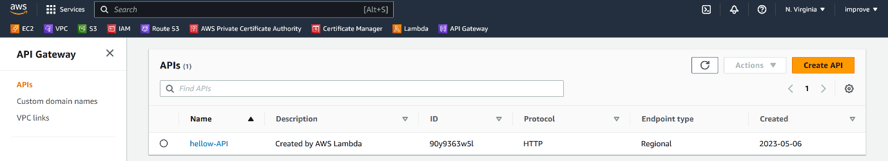

--- click on create API.

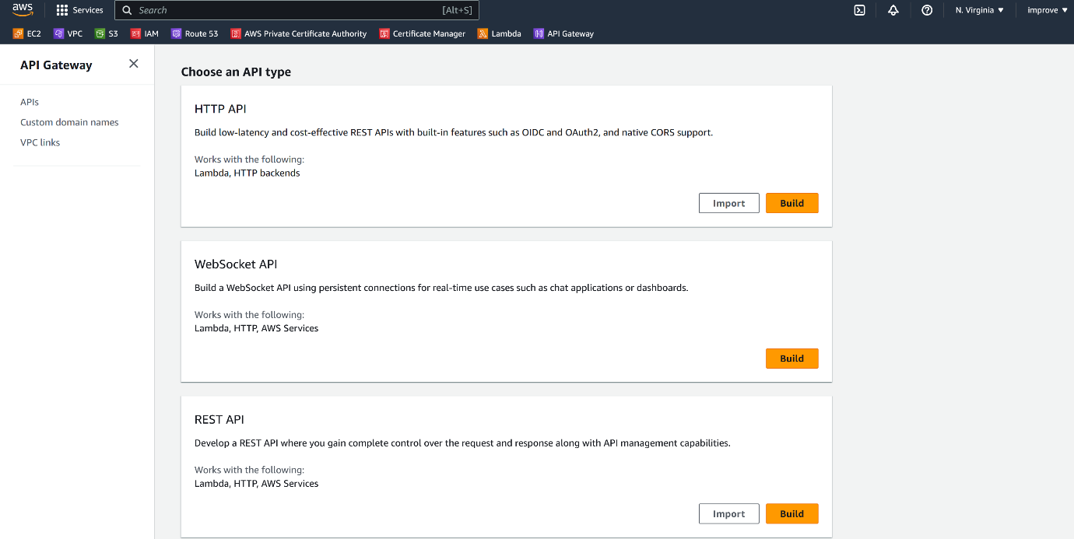



* So, let us go ahead and get a new API. Now, when I want to create a new API, I can choose one from different types of APIs. There is a rest API and rest API private and web socket APIs. REST API was the one that we had some time ago but AWS had to also introduce this REST API type, which is a low latency and cost-effective rest API. the difference between HTTP API and REST API is that, you know, some of the features of Rest API are not included in a HTTP API, but the benefits of HTTP API is it has a very low latency and it is highly cost effective.
* the rest api private is nothing but accessing the resources in your private data network such as HTTP Service, AWS Services or LAMDA, which are residing inside your VPC or virtual private network.
* Now, if you want to create a web sockets API, then you can choose this WebSocket API so you can have some real time communication going on.
* Now there is this another managed service called AWS App Sync, which is really useful if you want to build a real time grape QL API as well.
* Now let me select build with the **rest API type**.

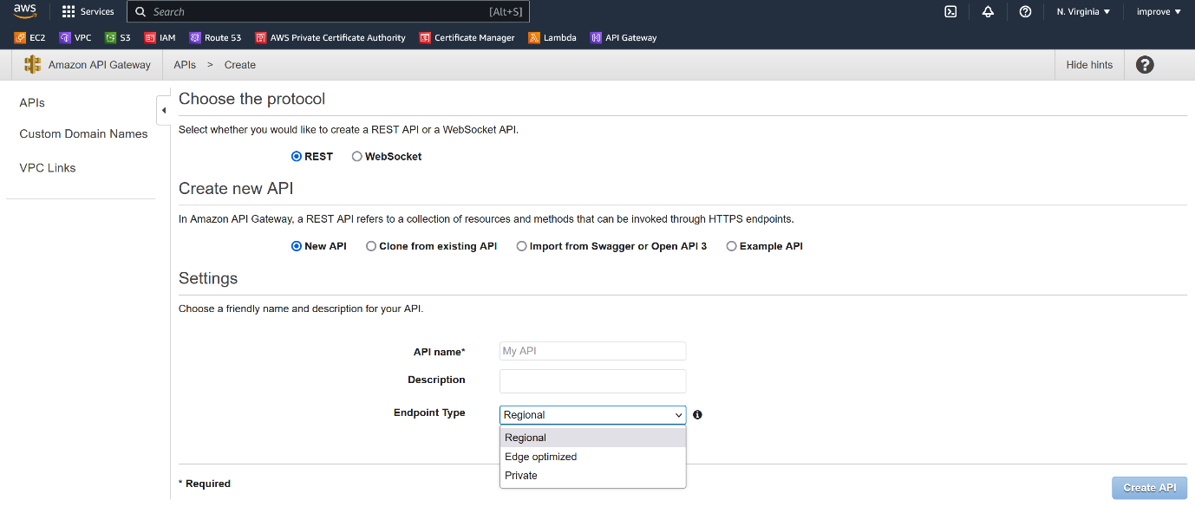

select the endpoint type. Now there are multiple types of endpoints.

--- **Regional**

There is this regional endpoint that means this APIs in the region that we define here, in this case, NORTH Virginia or us-east-1.

--- **edge optimized one**

We can select an edge optimized one. Now, this is particularly useful if you have users accessing your API from all around the world because edge optimized case API gateways access through cloudfront services. So, cloudfront is a content distribution network that is spread across the world.

So, your users can access your APIs with minimum latency.

--- **private**

it is not exposed to outside world and it is usually used if you have an application architecture. We had a one component can talk to another component through a private API.

**Vpc links**

I just want to touch VPC links as well. VPC links is essentially if we want to access resources in your private network, that means your virtual private cloud or VPC. Then you can create a VPC link and access to service privately but that is out of the scope of this course.